Making it easier to focus on reading and typing tasks
You can use the settings on the Make it easier to focus on tasks page in the Ease of Access Center in Windows 7 and Windows Vista to reduce the amount of information on the screen and to help students focus on reading and typing tasks.
In Windows 7 or Windows Vista, open the Make it easier to focus on tasks page by clicking the Start button , clicking Control Panel, clicking Ease of Access, clicking Ease of Access Center, and then clicking Make it easier to focus on tasks.

Checking spelling and grammar in Office programs
In Microsoft Office 2010, the Spelling & Grammar command is on the Review tab. Also on the Review tab, are the Research, Thesaurus, and Translate commands which also may be helpful for students.
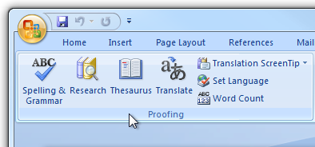
- Speech recognition programs allow computer navigation by voice rather than entering data by keyboard or mouse. You can still use a mouse and keyboard as well as voice, to enter data, write text, and navigate applications. Students who have difficulty typing or reading text because of a learning, language, or mobility impairment can often successfully work on a computer with the use of speech recognition. Speech Recognition is available in Windows 7 and Windows Vista. Some may prefer or require a more robust speech recognition program, such as Dragon NaturallySpeaking.

