Technology_helps_dyslexics_decode_written_word

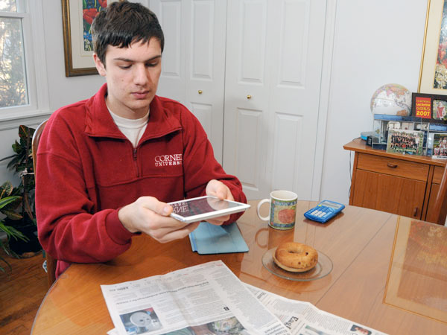
Kevin Riordan, Inquirer Columnist Sunday, November 30, 2014, 1:09 AM

I remember yearning to read the comics in the Sunday paper.

But the hieroglyphs inside the speech balloons remained inscrutable, until - on a sunny morning in Miss O'Shea's class - I finally grasped that a-n-d on the page and "and" in conversation meant the same thing.

A eureka moment for Brian Meersma arrived when his grandfather read aloud from the book the severely dyslexic boy, then in seventh grade, was having to decipher, word by laborious word.

"I said something like, 'I didn't know this was such a good book!' " recalls Meersma, 18, of Princeton Junction, a freshman at Cornell University.

He credits assistive technology - particularly text-to-speech translation software - with helping him better comprehend the written word.

There are even apps that allow him to upload scanned images of, say, classroom materials, and then download and read a text that's highlighted in sync with an audio narration.

Meersma has made public presentations about these and other wonders in a YouTube video for Advancing Opportunities, a nonprofit advocacy organization in Mercer County.

It's all part of a grassroots effort in New Jersey and nationwide to educate the public and people with "print disabilities" about the value of assistive technology.

"It's not a crutch, as some people seem to think," Meersma's mother, Kathy Stratton, says. Enabling dyslexic students to listen to text can work well in concert with conventional remedial reading instruction, she insists: "I don't see them as mutually exclusive."

Dyslexia is a learning disability that affects how a person perceives and processes symbols, such as printed words. The condition was first identified in the late 19th century; in recent decades, it has become more widely recognized and somewhat better understood.

"I didn't recognize the red flags at first," Stratton says, noting that although Brian needed speech therapy at age 3, he was bright and eager to learn.

"He couldn't understand the concept of words rhyming," she recalls. "But he was talking about things well above his grade level."

Dyslexics often find spelling a profound challenge, and Meersma was no exception. He was diagnosed in third grade, and the following year he began using a word-processing program with spell-check.

"Until then, I really couldn't express myself in writing," he says. Adds his mother, "Brian was so excited to be able to do things he hadn't been able to do."

Three years ago, Stratton, a psychologist, helped organize Decoding Dyslexia-NJ among a group of Mercer County parents. The group has since gone national, with chapters in 48 states.

Decoding Dyslexia-NJ also helped lobby the New Jersey Legislature to approve, and Gov. Christie to sign, dyslexia-related bills to provide student screening and teacher training in public schools.

Widespread use of smartphones and tablets has made text-to-speech services more readily available than just a few years ago.

"The technology has been around for a while," says Fred Tchang, Advancing Opportunities' director of assistive technology. "What's new is the opportunity that the pervasiveness of it represents. We just want people to know what's possible."

When Meersma was in high school, a printed classroom handout meant "he would have to run to the resource room to scan it" for text-to-speech conversion, Stratton says.

At Cornell, "my classes are going really well, and the services for students with disabilities are excellent," Meersma says.

Before he embraced assistive technology, "frustrated was a good word for how I felt," he says. "I was always wanting to learn more."

At Cornell, the learning process has become "seamless," he says.

Like the process that began for me in that sunny New England classroom more than a half-century ago, when the written word became intelligible to me for the first time. I'm glad Meersma and other people with dyslexia can share that gift, too.

