Accessibility in Windows 7
Windows 7 includes accessibility options and programs that make it easier to see, hear, and use your computer including ways to personalize your PC.
Windows 7 includes significant accessibility improvements. Magnifier now includes a lens mode and full-screen mode. On-Screen Keyboard can be resized to make it easier to see and includes text prediction. Windows 7 also gives you more ways to interact with your PC by taking advantage of new strides in speech recognition and touch technology.
Find more information at www.microsoft.com/enable/products/windows7/.
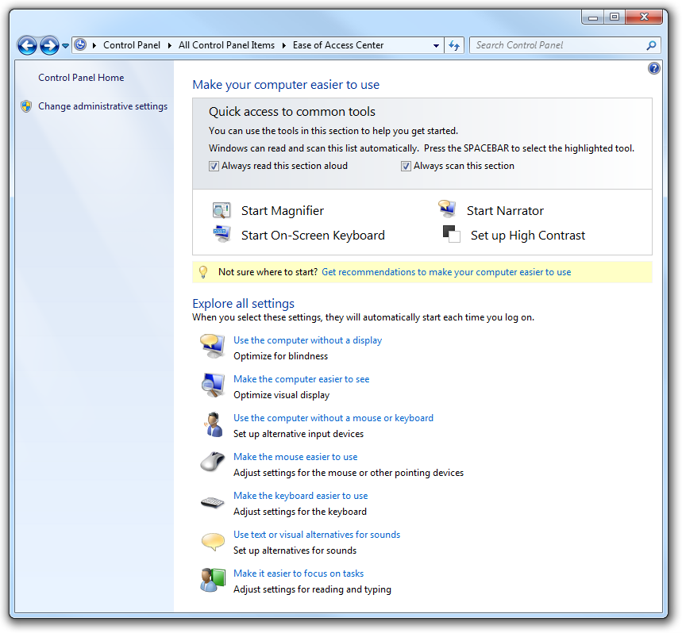
Figure 3-1. Windows 7 Ease of Access Center

Overview of Accessibility Features in Windows 7
Feature | Description
Ease of Access Center | A central location to explore accessibility settings and programs to make your computer easier to use. The Ease of Access Center can be found in the Control Panel by selecting Windows logo key +U and when logging on to Windows.  The Ease of Access Center includes:  - Quick access to common tools. Start Magnifier, On-Screen Keyboard, Narrator, and High Contrast quickly.  - Get recommendations to make your computer easier to use. An optional questionnaire provides a personalized list of recommended settings based on your answers to a series of questions about your eyesight, dexterity, hearing, and more. A custom list of recommended settings is provided so you can choose which options you want to try.  - Explore all settings by category. Instead of looking for accessibility settings in various places, settings are organized so you can explore how to:  - Use the computer without a display  - Make the computer easier to see  - Use the computer without a mouse or keyboard  - Make the mouse easier to use  - Make the keyboard easier to use  - Use text or visual alternatives for sounds  - Make it easier to focus on tasks
Speech Recognition | Enables you to interact with your computer using only your voice, significantly reducing the use of a mouse and keyboard while maintaining overall productivity. Dictate documents and e-mail, browse the Web, and command programs by saying what you see. Interactive training guides you through an easy setup process and will familiarize you with the voice commands.
Magnifier | Enlarges portions of the screen making it easier to view text and images and see the whole screen more easily. Magnifier in Windows 7 now includes full-screen mode, lens mode, and docked mode.  The magnification quality is improved and you can set the magnification level up to 16 times the original size and choose to track what you magnify by movement of your mouse, the keyboard, or text editing. Options includes:  - Choose where Magnifier focuses so that it follows the movement of the mouse cursor, keyboard focus, or text editing  - Change the zoom level  - Set the zoom increment  - Set the lens size  - Turn on color inversion for better screen legibility  - Display the Magnifier toolbar
Make items on the screen appear larger | Make the text and other items, such as icons, on your screen easier to see by making them larger. You can do this without changing the screen resolution of your monitor or laptop screen. This allows you to increase or decrease the size of text and other items on your screen while keeping your monitor or laptop set to its optimal resolution.
On-screen keyboard | Displays a visual keyboard with all the standard keys. Instead of relying on the physical keyboard to type and enter data, you can use On-Screen Keyboard to select keys using the mouse or another pointing device.  On-Screen Keyboard in Windows 7 can be resized and customized to make it easier to see and use. On-Screen Keyboard now also includes text prediction in eight languages. When text prediction is enabled, as you type, On-Screen Keyboard displays a list of words that you might be typing. Options include:  - Change how information is entered  - Set On-Screen Keyboard to use audible clicks  - Use a numeric keypad  - Enable text prediction
Speech Recognition | Command your PC with your voice including the capability to dictate into almost any application. You can dictate documents and e-mail and surf the Web by saying what you see. An easy setup process and an interactive tutorial are available to familiarize you with the speech commands and train your computer to better understand you. Options include:  - Dictate text using Speech Recognition  - Use the dictation scratchpad  - Add or edit words in the Speech Dictionary  - Use common commands
Windows Touch | While great for a lot of tasks, using a keyboard and mouse is not always the easiest way to do things. With Windows 7, if you've got a touch-screen monitor, you can just touch your computer screen for a more direct and natural way to work. Use your fingers to scroll, resize windows, play media, and pan and zoom.
Narrator | Windows comes with a basic screen reader called Narrator, which reads text on the screen aloud and describes some events (such as an error message appearing) that happen while you're using the computer. You can find Narrator in the Ease of Access Center. Options include:  - Choose which text Narrator reads aloud  - Change the Narrator voice  - Start Narrator minimized
Keyboard shortcuts | Keyboard combinations of two or more keys that, when pressed, can be used to perform a task that would typically require a mouse or other pointing device. Keyboard shortcuts can make it easier to interact with your computer, saving you time and effort.
Mouse Keys | Instead of using the mouse, you can use the arrow keys on the numeric keypad to move the pointer.
Sticky Keys | Instead of having to press three keys at once (such as when you must press the CTRL, ALT, and DELETE keys simultaneously to log on to Windows), you can press one key at a time when Sticky Keys is turned on.
Filter Keys | Ignore keystrokes that occur in rapid succession and keystrokes that are held down for several seconds unintentionally.
Visual Notifications | Replace system sounds with visual cues, such as a flash on the screen, so system alerts are announced with visual notifications instead of sounds.
Captions | Get information via animations and video that some programs use to indicate that activity is happening on your computer.

