Hearing Impairments

Accessibility Features in Windows
Accessibility features for those with hearing impairments include changing notifications from sound to visual notifications, volume control, and captioning. These features are available in Windows 7 and Windows Vista. Visual notifications (Sound Sentry) and captions (Show Sounds) allow users to choose to receive visual warnings and text captions, rather than sound messages, for system events such as a new e-mail message arriving.
Accessibility features helpful for students who have hearing impairments include:
- Adjusting volume
- Changing computer sounds
- Using text or visual alternatives for sounds

Adjusting volume
Although most speakers have a volume control, you can also control speaker volume using Windows. The quickest way to change the speaker volume for your computer is to click the Speakers button in the notification area of the taskbar, and then move the slider up or down to increase or decrease the
speaker volume.

To adjust overall sound volume in Windows 7 or Windows Vista:
- Open Volume Control by clicking the Start button , clicking Control Panel, clicking Hardware and Sound, and then, under Audio Devices and Sound, clicking Adjust system volume.
- Under Main Volume, move the slider up or down to raise or lower the volume.

Change computer sounds
You can select the sounds that play when certain events occur on screen. This is helpful for students who have trouble hearing some sounds—high or low-pitched sounds, for example, or sounds associated with other devices. To change sounds in Windows 7 or Windows Vista:
- Open Sound by clicking the Start button , and then clicking Control Panel. In the search box, type sound, and then click Sound.
- Click the Sounds tab.
- In the Sound Scheme list, click the sound scheme that you want to use, and then click OK.
To change an individual sound, select an event (under Program Events) to which you want to assign a new sound. You can click Test to hear each sound.
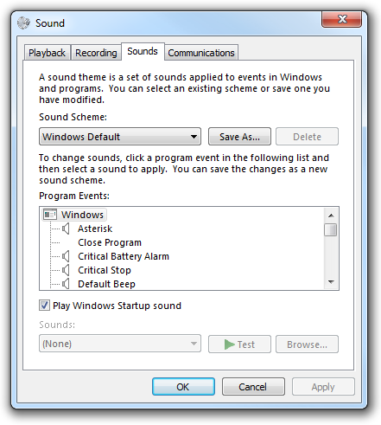
Figure 2-8. Sound options

Use text or visual alternatives to sounds
Windows provides settings for using visual cues to replace sounds in many programs. You can adjust these settings on the Use text or visual alternatives for sounds page in the Ease of Access Center.
- In Windows 7 or Windows Vista, open the Use text or visual alternatives for sounds page by clicking the Start button , clicking Control Panel, clicking Ease of Access, clicking Ease of Access Center, and then clicking Use text or visual alternatives for sounds.
- On the Use text or visual alternatives for sounds page, select the options that you want to use:
  - Turn on visual notifications for sounds. This option sets sound notifications to run when you log on to Windows. Sound notifications replace system sounds with visual cues, such as a flash on the screen, so that system alerts are noticeable even when they're not heard. You can also choose how you want sound notifications to warn you.
  - Turn on text captions for spoken dialog. This option causes Windows to display text captions in place of sounds to indicate that activity is happening on your computer (for example, when a document starts or finishes printing).
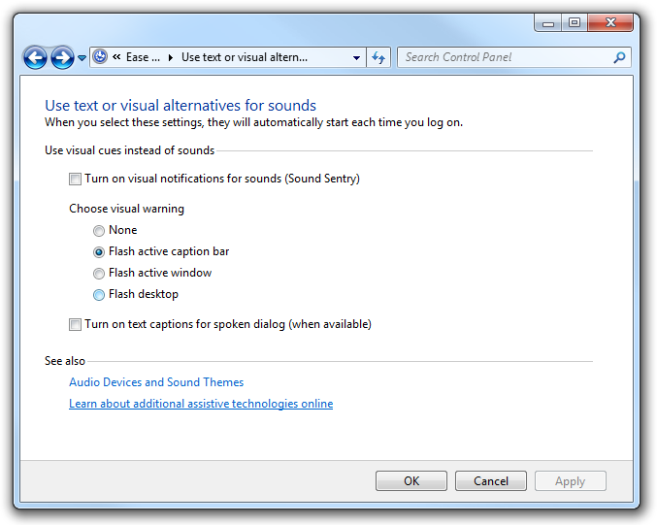
Figure 2-9. Use text or visual alternatives for sounds page in the Ease of Access Center

